Warren Jaftha

GROUP-19  Student Number-219005303

Project 2(Individual assignment)

CONTENT PAGE

Introduction and Tasks…………………………………Page-3

REFLECTION…………………………………………Page 3-4

Functional Requirements………………………………Page 4-5

Mind-Map…………………………………………..…Page 6

WireFrame…………………………………………….Page 7-8

FlowChat……………………………………………..Page 9

Psuedocode………………………………………….Page 10-11

ERD-Diagram……………………………………….Page 12

First look of Pages…………………………………..Page 13-14

Coding evidence…………………………………….Page 15-16

Certificate…………………………………………..Page 17

Conclusion………………………………………….Page 18

INTRODUCTION

My name is Warren Jaftha-219005303 I am the leader for this assignment. Our task as a group was to create a app that would solve a problem within the community so as a group we had multiple discussions and we decided that the problem that we would like to solve is **unawareness of loadshedding times** and the people specifically that we want to help is **CPUT students of district 6 campus.**

**TASKS**

The task for this assignment that I was given was to create a online database using the built in software called firebase and to **create a Registration page** to capture users info when they sign up for an account.

Along with that I was also given the task of **creating a Forgot password page** this page will be linked with Login page and will also use the built-in software called **firebase** which will send users a link to their email that they used to sign up with when they created their account, if they follow the link then they will reset their password.

**REFLECTION**

**Phone**: Nexus 6-API 30

**Phone Size**: Normal

**Software Used**: Android Studio

**Programming language:** Java

**Apps Purpose**: make C.P.U.T application development students aware of Loadshedding times based on their timetable.

For my registration page and reset page to work and function properly on final submission my group (including myself) will be using a built-in software called “**Firebase**” which is located in android studio. Our app needs this software to function 100% (functional requirement).

**So, what is Firebase?**

Firebase is a Backend-as-a-Service (Baas). It provides developers with a variety of tools and services to help them develop quality apps, grow their user base, and earn profit. It is built on googles infrastructure.

Firebase is categorized as a NoSQL database program, which stores data in JSON-like document.

To put it in simple terms what this software’s purpose is in our app is to serve as a safe and secure online database that will store individuals Information that they have inputted when creating an account in the registration page as well as locating information when they try to login.

**Functional Requirements**

**Register Page**

* For the registration page users should be able to enter their details into the text fields
* The registration button when pressed will save the users information to the database and will take the user to the **function page**.
* The Registration page should only allow users to sign-up with a valid email account.
* The link **have you got an account?** Located on the registration page should take the user back to the login page.
* When user signing up for account enters details the registration page will capture their details and save It into the firebase software database.

**Reset Password**

* For the Reset password page users should be able to enter their email into the text field.
* On the reset password page when the reset password button is pressed then a confirmation email should be sent and return the user back to the login page.
* The system should not allow users to make an account with the same student number or student email.
* The Forgot password page should also only allow users to use a valid email and not a fake one.

**Functionality of app**

* We need a up-to-date timetable of C.P.U.T students that they follow for classes.
* We need an actual up-to-date Loadshedding schedule for different days.
* For the login page and registration page to function with a database we need to use the software Firebase.
* For all of our pages to have access to one another’s we need to have functioning buttons which are all link together with all the pages.

**COLORS**

The Color scheme for our app design that we chose was **THE ANALOGOUS SCHEME.**

ANALOGOUS SCHEME is a combination of colors that when you look at the color wheel are found next to one another. One color is dominant and then the other colors which you have chosen would enrich the scheme.

Why?

The reason why we chose this color scheme was because it is very **harmonious** and **very pleasing to the eye** which is good when using it in app design.

C:\Users\a\Downloads\cyan.PNGThe colors that we are choosing is

**CYAN**  **RGB**: 0,255,255 **HEX**: 00FFFF

C:\Users\a\Downloads\blue.PNG

**BLUE**  **RGB**: 0, 0, 255 **HEX**: 1800FF

C:\Users\a\Downloads\cornflower.PNG

**CORNFLOWER BLUE** **RGB**: 100,149,237 **HEX**: 6495ED

* **Background color**-The background color will be blue or an image that will be blue to match the analogous color scheme.
* The border surrounding our database will have a white color to give it a distinct and attractive look.
* With the **Reset password page (forgot password**) when the user forgets their password and enters their email the software sends a confirmation email to their email address resetting their password.

DESIGN REQUIREMENTS

**Mind Map-Planning**

Marvin:

Functionality Page

Warren:

Registration Page and Reset Page

Edvalter:

About Page

Ameer:

Login Page

CPUT LOADSHEDDING ALERT!!

Brent:

Contact Page

**DESIGN REQUIREMENTS**

**WIREFRAME(REGISTRATION PAGE)**

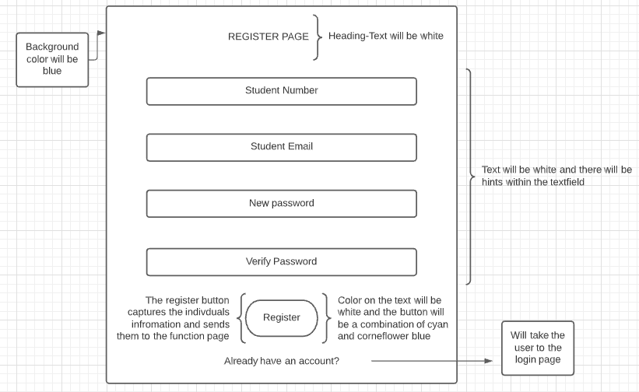

TEXTFIELDS-Each one of these text fields will have a maximum of 40 characters.

**FUNCTION**

The registration page will capture the individual’s details and save it into our **online database** which I have created using Firebase after the user is registered the individual will be taken to the login page to sign in as they now have an account created.

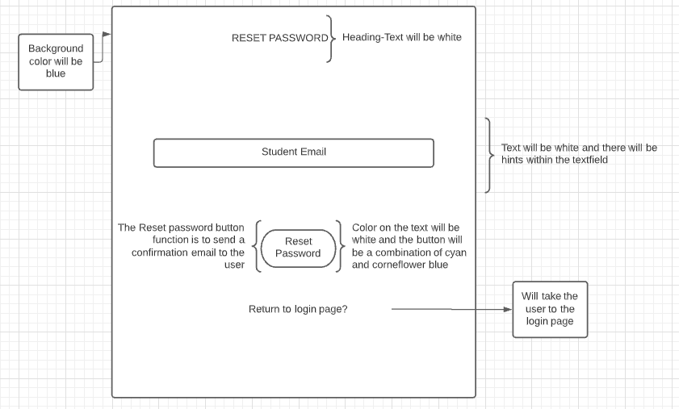**FIREFRAME(RESET PASSWORD)**

TEXTFIELDS-Each one of these text fields will have a maximum of 40 characters.

**FUNCTION**

When a user forgets their password then from the login page, they will be directed to the forgot password page through the link and when the user types in their email (the one that the created the account with) then the software called firebase will send the user an email with a link and when the link is followed then the individual will be able to change their password which will then be updated in the online database.

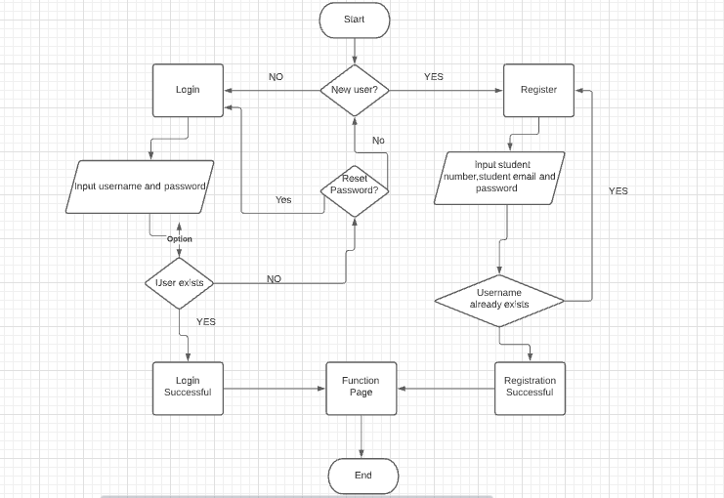**FLOW CHART and PSEUDOCODE**

**REGISTRATION PAGE PSUEDOCODE**

**BEGIN**

**INPUT**

Display “Student number”

Enter Student Number

Display “Student Email”

Enter Student Email

Display “New password”

Enter New password

Display “Verify Password”

Enter Verify Password

**PROCESS**

**If**

All data is inserted correctly into the fields.

**then**

Data gets retrieved from the text fields and the new user is created.

**Else if**

Certain fields are left empty.

**Then**

No data is retrieved, no user is created.

**OUTPUT**

Users Account is created and is taken to the Registration Page.

**END**

**FORGOT PASSWORD PAGE PSUEDOCODE**

**BEGIN**

**INPUT**

Display “Student Email”

Enter Student Email

**PROCESS**

**If**

email is inserted.

**Then**

Data gets retrieved from the text fields and a verification email is sent to user.

**Else if**

No email is inserted.

**then**

No verification email is sent, and alert message is displayed

**OUTPUT**

The user receives the verified email then being able to reset their account.

**END**

**ERD Diagram**

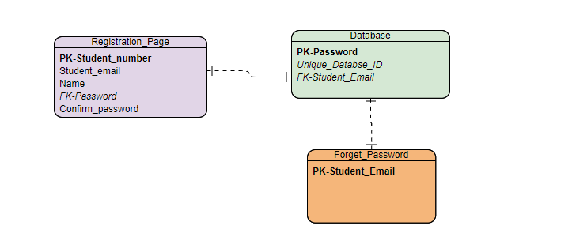

Simple ERD-diagram explaining how my registration and login page is connected to my database both of those pages have a 1:1 (one to one) relationship with the database that it is sending and requesting information from

**FIRST LOOK OF REGISTRATION PAGE**

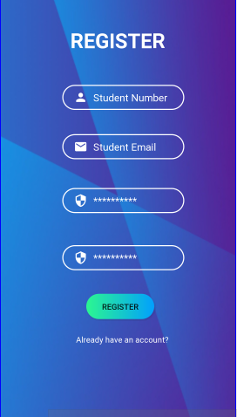

**FIRST LOOK AT RESET PASSWORD PAGE**

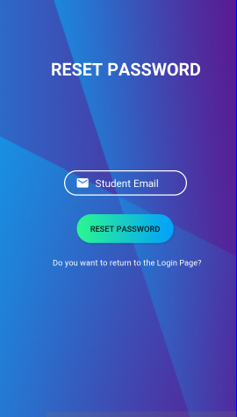

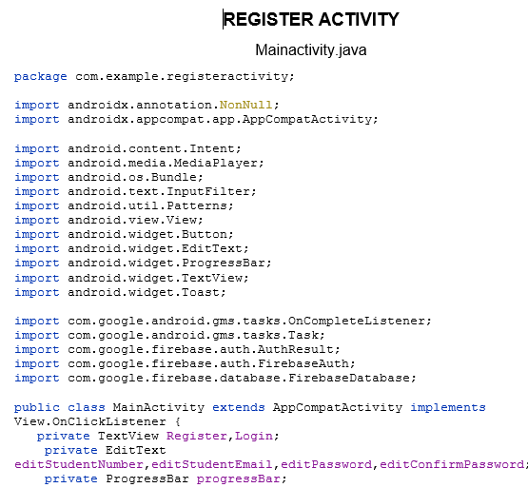CODING EVIDENCE

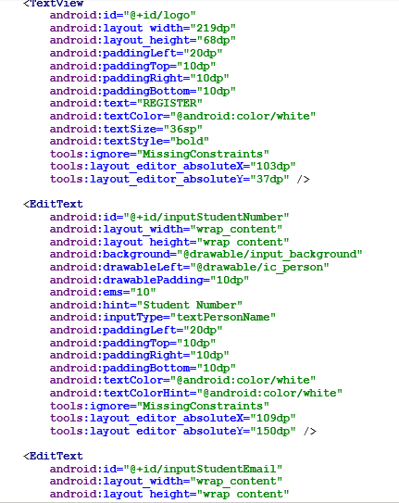

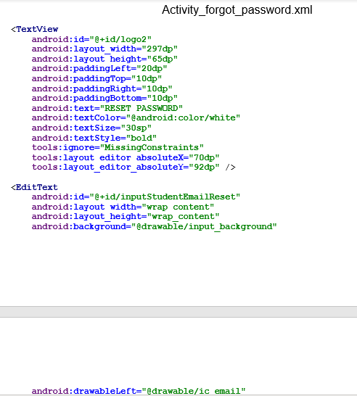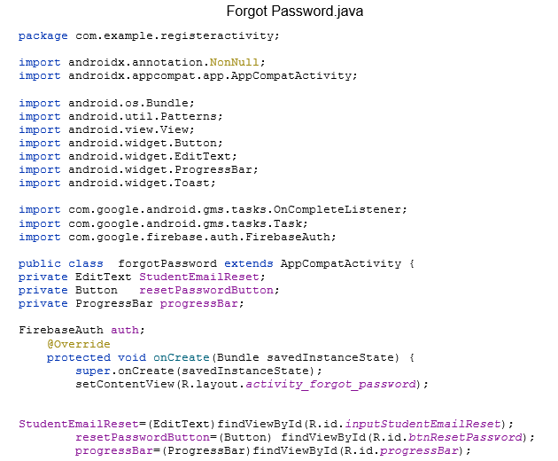

**CERTICATE**



CONCLUSION

Coming to the end of my report I hope whoever is reading it has a solid idea of what my responsibilities is in this task and what my final outcome will look like for my 2 pages when we hand in our final versions of our application thank you.

BIBLIOGRAPHY

Adoriasoft.-[Mobile App Design: 14 Trendy Color Schemes | by Adoriasoft | Medium](https://medium.com/@Adoriasoft/mobile-app-design-14-trendy-color-schemes-2669b5bb77d3)